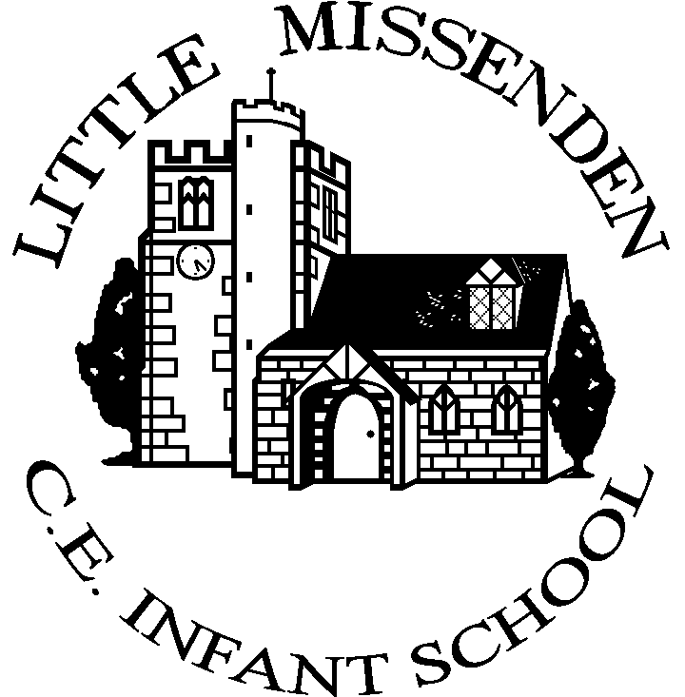

Newsletter:
Friday 24 October

As we reach the end of another busy half term, we want to take a moment to reflect on the fantastic achievements, events, and progress made across the school. We have watched our new children settle into the school environment, exciting events such as Vision Day and Harvest Festival, plus enrichment opportunities such as Forest School, Yoga and local walks.
The children have shown great curiosity, and commitment to their learning, and we are proud of everything they have accomplished. A huge thank you also goes to our dedicated staff, supportive families and local community.
Please take a moment to read our latest notices and news:
M&M Panto - Friday 7th November
“Oh yes it is!” Beauty and the Beast is coming to Little Missenden! The whole school will attend, so please ensure you return your consent form as soon as possible and at the latest Monday 3rd November. PSALMs would also welcome your donation for tickets – just click the link below to make the payment:
https://app.classlist.com/parent/#/events/view/1385430837?s=81590664&utm_source=SCHOOL&utm_medium=SHARED_LINK
Club Notices
 | Time | Club | Class | Provider | Booking
Monday* | 3-4pm | Yoga Club | Rec, Yr 1, Yr 2 | Mrs Steele | yogacubs25@gmail.com
Tuesday | 3-4pm | Multi Sports Club | Rec, Y1, Yr 2 | Active Sport | https://www.sportsoftware.io/event?eventId=5492
Wednesday** | 3.05-3.35pm | French Club | Yr 1, Yr 2 | La Jolie Ronde | brownfjb@gmail.com
Thursday | 3-4.15pm | Art Club | Rec, Yr1 & Yr 2 | Mrs Sharp | Payment via ParentPay, email the school office to reserve your space
*please note there will be no Yoga Club on 24/11 and 1/12
** please note there will be no French club on 5/11
There are still a few places in all clubs, if you would like to sign your child up please contact the providers directly.
We are delighted that Art Club (for Robin and Owl Class children) run by Mrs Sharp will start after half term, on Thursdays from 3-4.15pm. Places will be offered on a first come first served basis. If your child transfers to After School Club afterwards you will need to pay for the second hour. More details are on the flyer below. If you wish to sign your child up please email the office and the payment item will then be assigned to your ParentPay account.
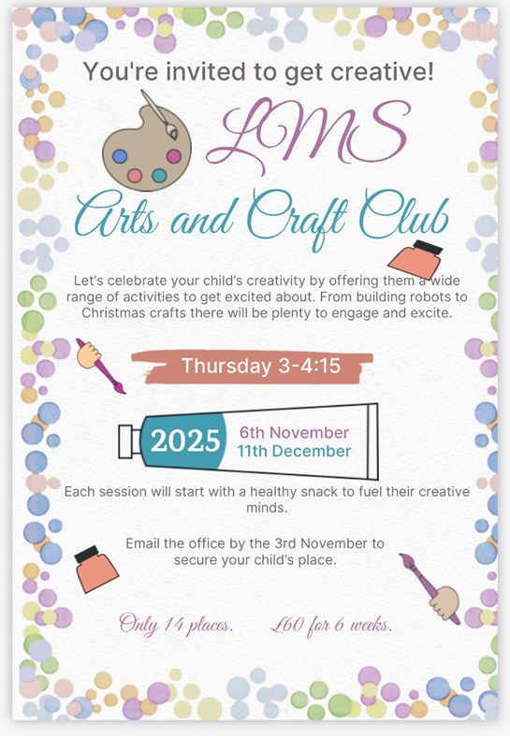
School Photos
Don’t forget to order your school photos, the deadline for orders with free return to school is 29th October, just go to www.tempest-orders.co.uk and enter your unique code from the photo proof.
If you need any assistance in ordering your photos, feel free to contact Tempest on 01736 751555 (option 5).
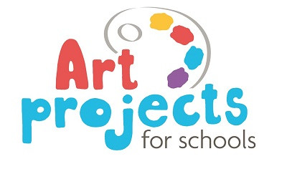
APFS Christmas Card Project
The closing date for Christmas Card and gift orders is 31st October, so don’t forget to place your order. Thank you to everyone who has ordered so far - you are helping raise valuable funds for the school.


Children in Need
This year we are having our Children in Need fundraising day on Thursday 13th November. Children are invited to come in something spotty or the Children in Need colours: red, green, blue or yellow. In return please make a donation via the ParentPay link in November.

Franks Coffee Truck

Just a reminder that Frank’s Coffee Truck dates for the rest of the term are as follows:
Thursday 13th November
Thursday 11th December

Every hot drink sold raises money for the school, so it is a great way to start the day with a good coffee whilst raising money for the school! Parents are welcome to enjoy their coffee on the playground (if the weather permits!).
Stay and Play 24 November
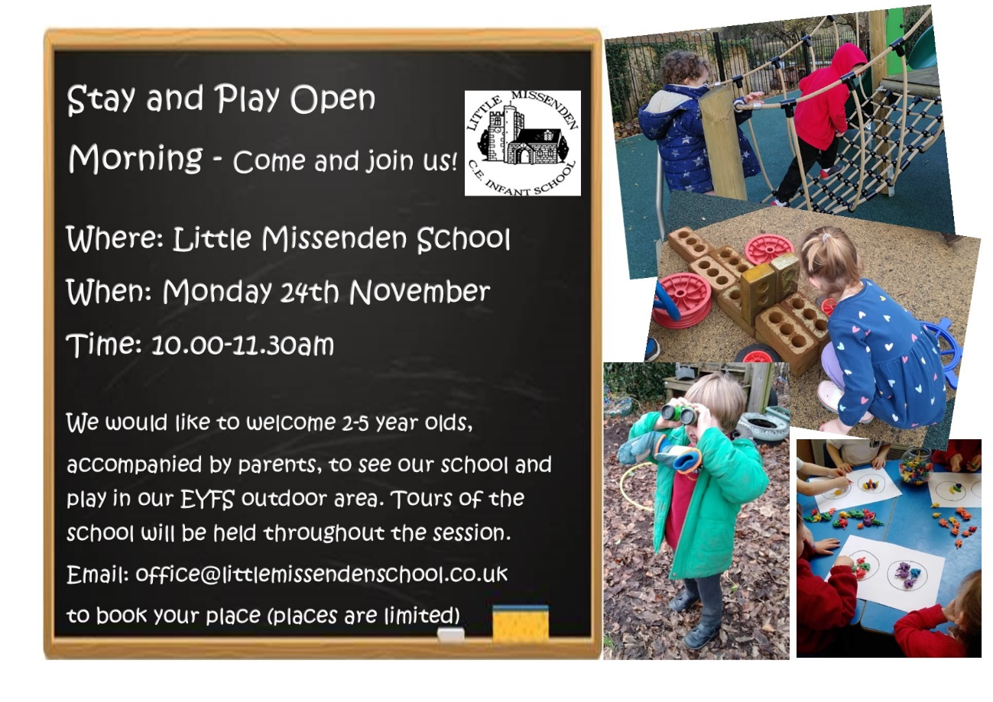


Instagram page
Some of you will have seen that we now have an Instagram page! Find us here: @littlemissendenschool

School News



Robins & Little Robins

We have been looking at Autumn and the changes we can see in nature. We had a walk around the village where we observed the changing colours of the trees and collected cones, acorns and conkers. We have made pictures from these natural materials. We have also created our own autumn water colour pictures and explored colour mixing through leaf printing.

Little Robins had fun conker rolling, making acorn and pumpkin pictures, leaf crowns and red and yellow colour mixing.

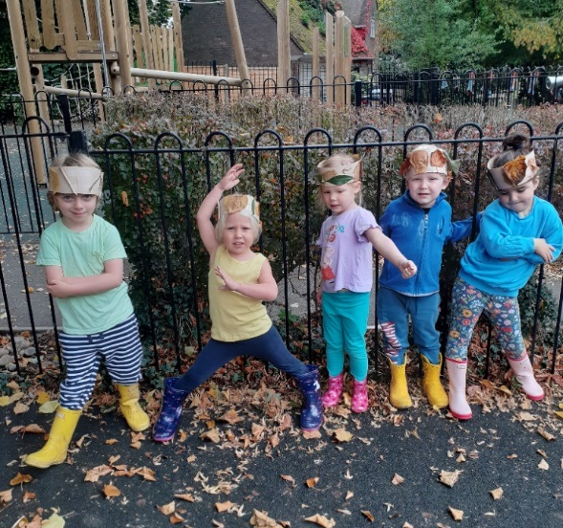
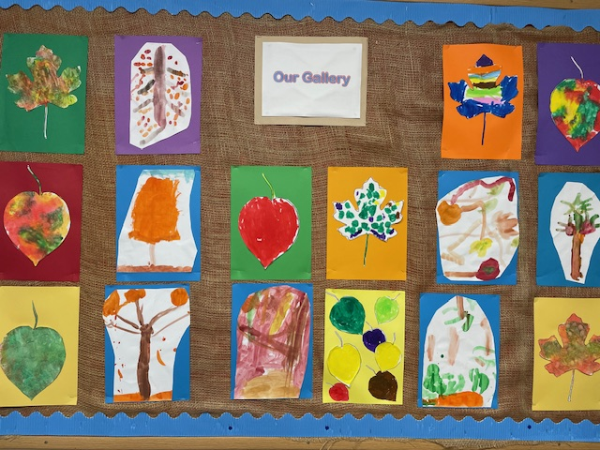

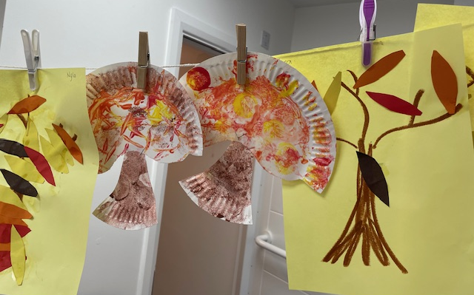
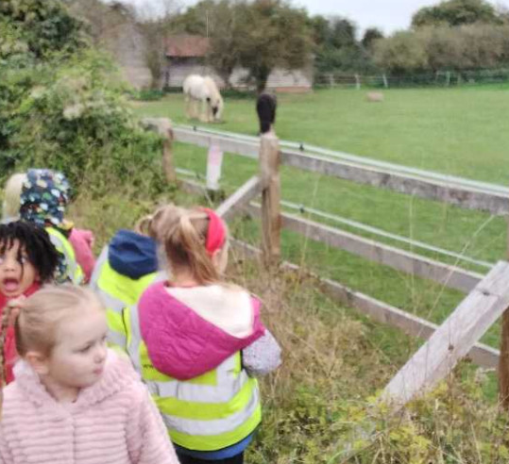

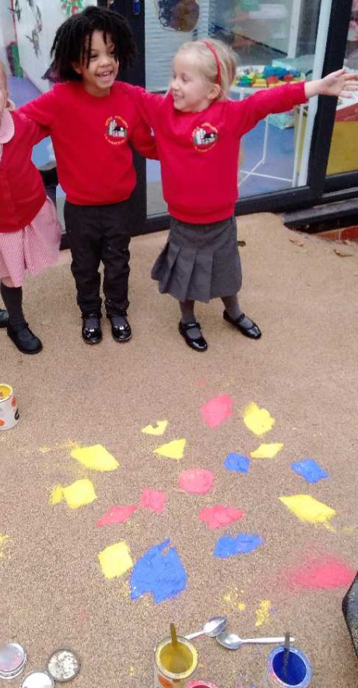
This week Robins and Little Robins have explored the celebration Diwali – we talked about the origins of the celebration, created Rangoli patterns with powder paint and had a go at some Indian dancing. The highlight was trying pakoras made by Ms Din!

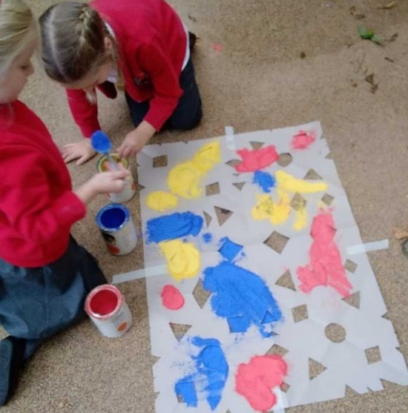
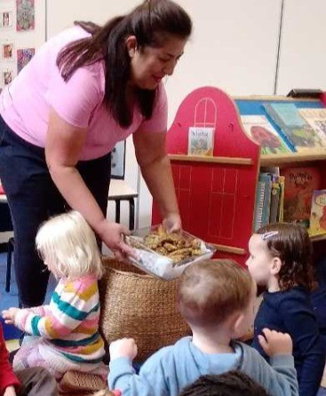


Owl Class

Owl Class have had a very busy half term!

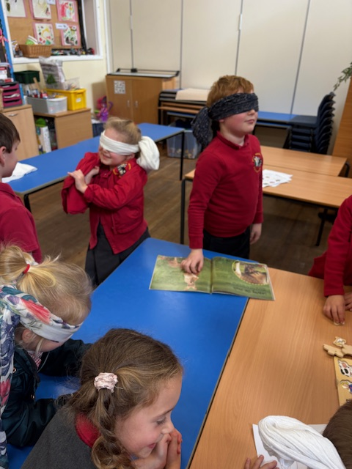
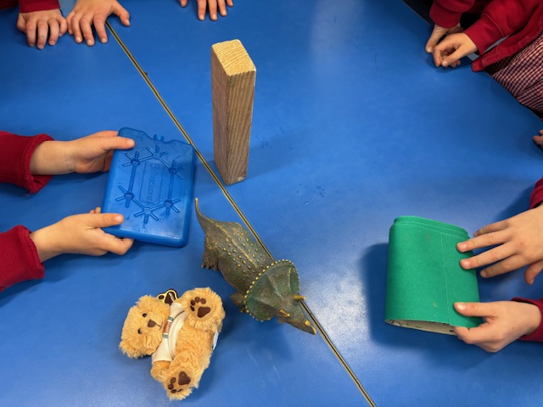
We've explored our senses during our science lesson, thinking about all 5 senses and enjoying the challenges of finding out what we could smell, taste and feel.
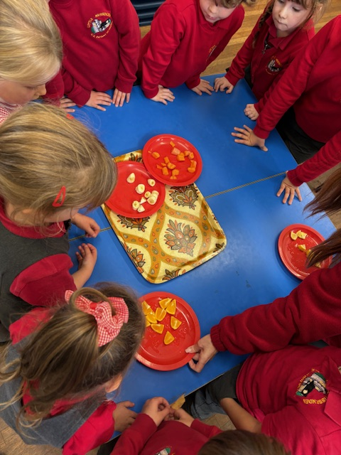

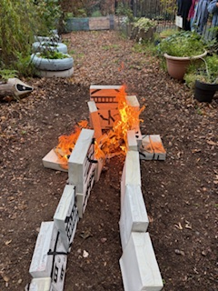
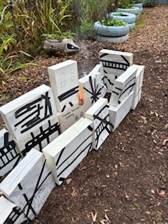

Our topic this half term was the Great Fire of London. We have explored how the fire has changed the way London was rebuilt and how our homes are now much safer. We made our own houses to represent the houses in Pudding Lane in 1666 and set fire to them to experience how fire could spread between houses back in 1666. You can see the video on our Instagram page!

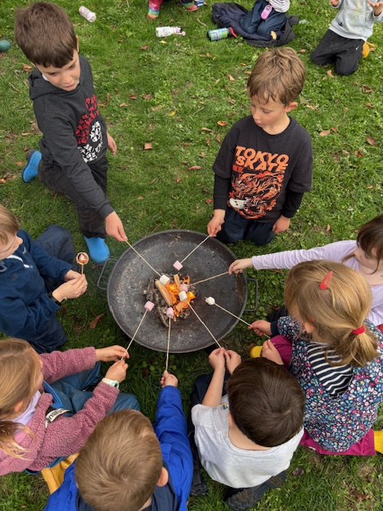

Owl class have enjoyed some varied Forest School experiences around the village including a visit to one of our governor’s Mrs Hill's orchard and arboretum. It was wonderful to sit watching the stream flow past, hear the chickens clucking in the neighbouring fields, explore the wood chip pile and dig in the soil heap. We constructed dens and enjoyed a snack break. We even managed to spot some Tudor houses with their exposed beams on the walk back to school.

On Friday we had our Forest School Fire, all the children had a chance to help build the fire and toast their own marshmallows.

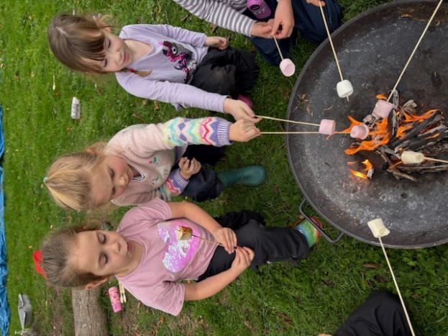
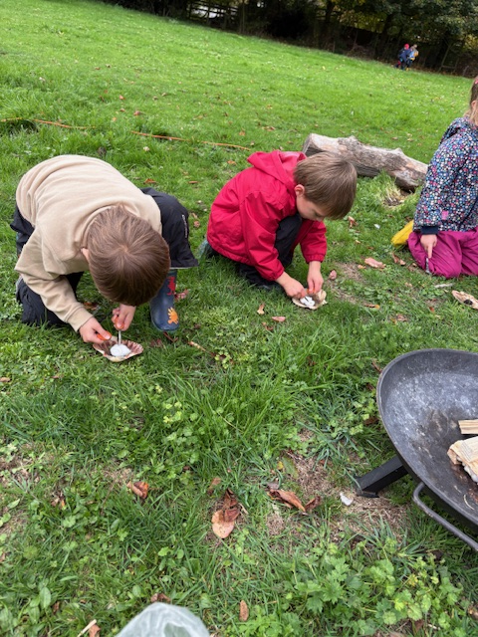
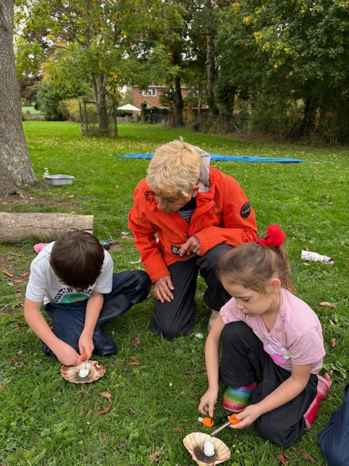

Art lessons have allowed us to explore Monet's paintings of his garden, recreating some of our very own paintings too. We have also looked at cityscapes and landscapes, using pastels to make a London cityscape sunset, after looking at Van Gogh's paintings

The Aviary – Wraparound Care

Opening Hours:

Breakfast Club with Mrs Guinea and Mrs Winston -
7:45 - 8:45 Monday - Friday

Afternoon Club with Mrs Sharp & Mrs Guinea -
15:00 - 18:00 Monday - Thursday
15:00 - 17:00 Friday

Snack times
"Little Bite" 15:00
"Feed the Birds" 16:15
"Still Peckish" 17:15

The half term has got off to a great start. Our new extended hours are proving to be very popular, particularly breakfast club. We have an array of cereals, toast, croissants and fruit available to offer and there are activities for the children to get busy with.

In the afternoon we do ensure that the children do not go hungry. Along with a big welcome, they are encouraged to sit down for a short period to relax with a story, whilst we get all the children signed in.

So, what do the children get up to in the Aviary in the afternoons? We spend as much time as we can outside where the children can play football, use the construction equipment or use the bikes and ride-ons from the Early Years area. But the adventure playground is always a big hit!

When indoors, Lego building and colouring are firm favourites, but we also have games, reading books and jigsaw puzzles available.

The wrap around staff are always available to answer any questions.
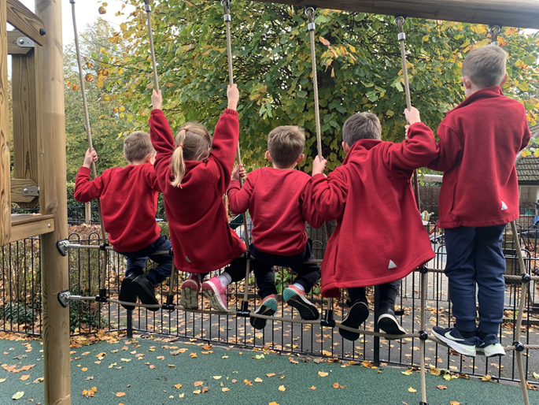
PSALMS NOTICES
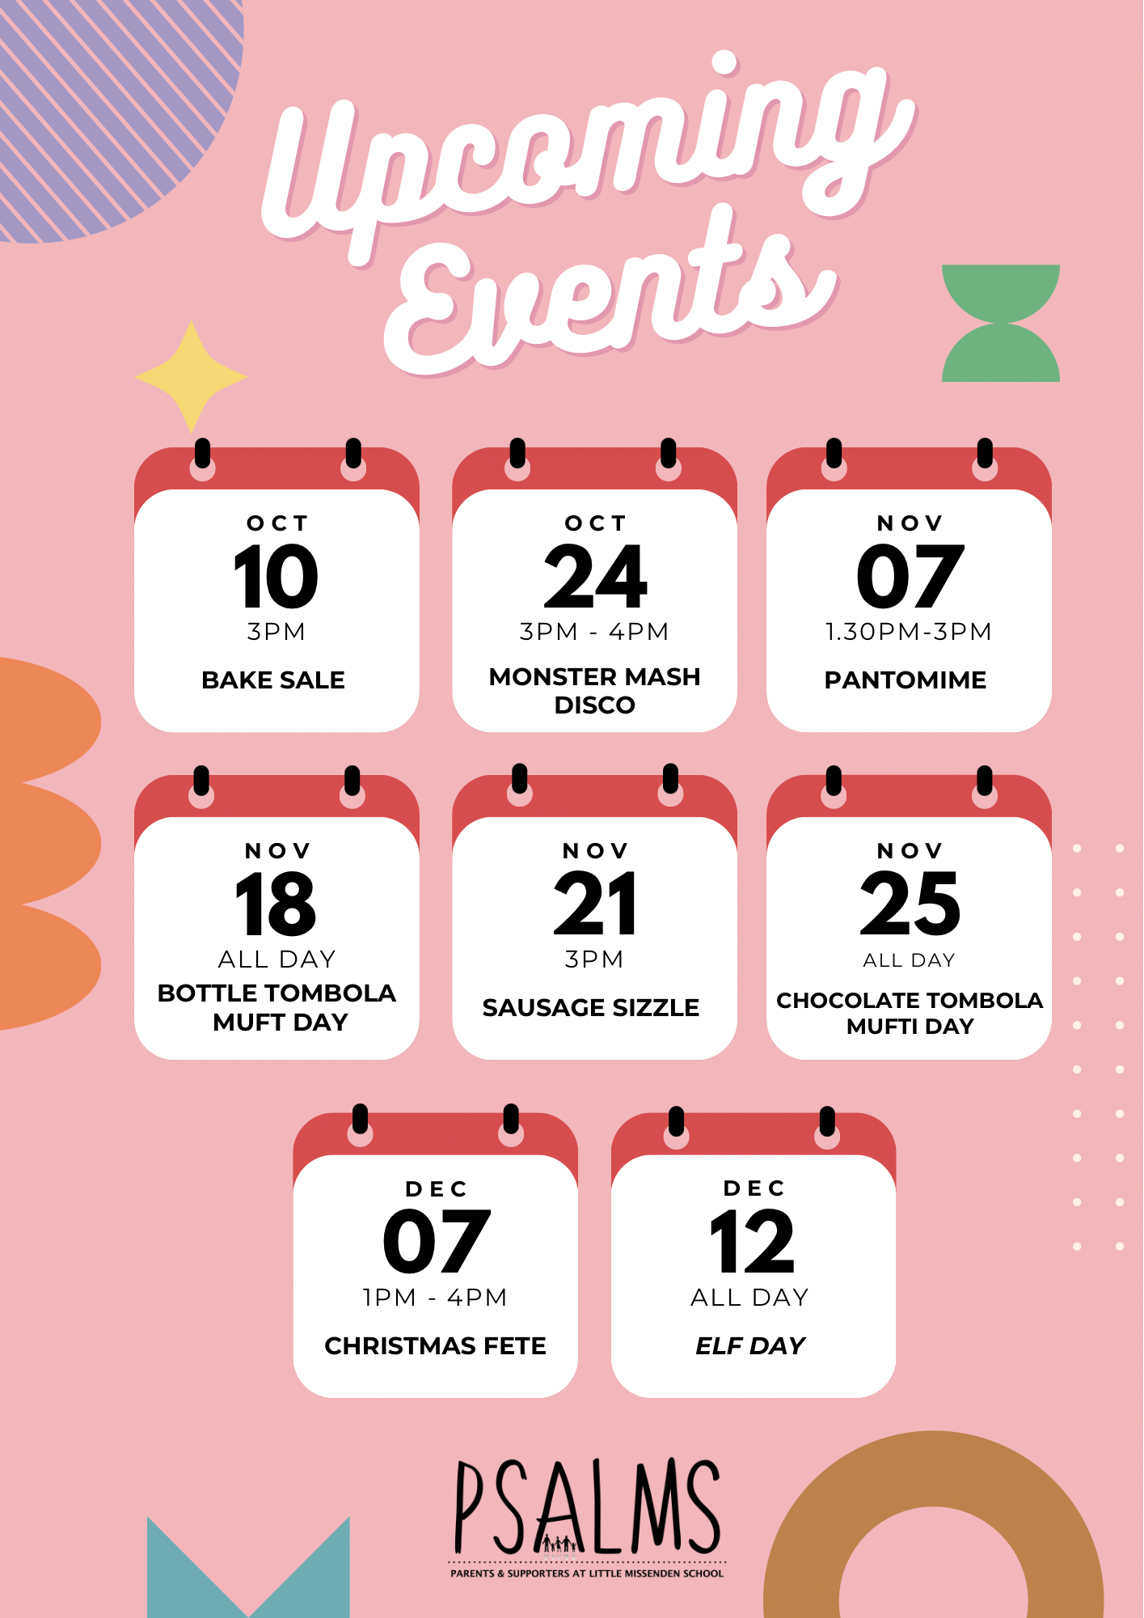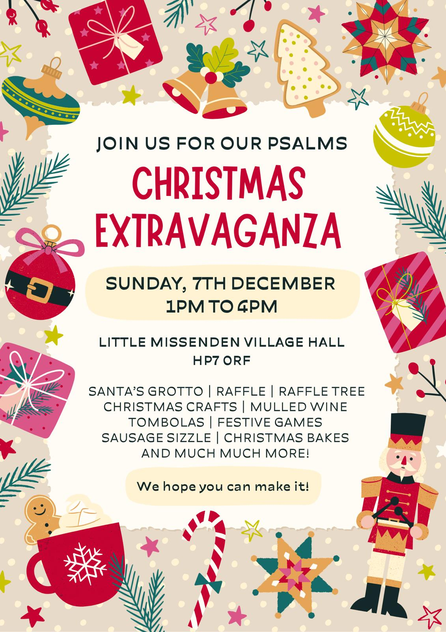

As it gets colder and the nights shorter, we get ever closer to our Christmas Fete, run by PSALMS, our PTA. This is one of the main fundraising events of the school year and hugely contributes to all the fun and developmental curriculum at the school. Without these events many of these activities would not happen.

This event cannot run without you! So please volunteer wherever you can using the link below to choose your timeslot. All your help and support is greatly appreciated!
https://www.signupgenius.com/go/70A084AABA822A4FB6-59524327-christmas

Enjoy your half term break, we look forward to seeing you all for the "festive" part of the year.

Diary Dates for next half term:
Date | Event
Friday 24th October | Monster mash disco/School Closes for Half Term
Monday 3rd November | School Re-opens
Friday 7th November | Whole School to Pantomime at Village Hall
Thursday 13th November | Franks Coffee Truck  Children in Need Day
Friday 14th November | Owl Class – Football Festival
Tuesday 18th November | Mufti day (bottle for tombola)
Friday 21st November | PSALMS Sausage Sizzle
Tuesday 25th November | Mufti day (chocolate for tombola)
Friday 28th November | Whole School Waddesdon Manor Trip
Tuesday 2nd December | Nativity Performance – 1.15pm
Wednesday 3rd December | Nativity Performance – 9.15am
Sunday 7th December | PSALMS Christmas Fair 1-4pm
Friday 12th December | Elf Day
Thursday 18th December | Christmas lunch and party
Friday 19th December | Church Service 9.15am  School Closes for Christmas Break 1.15pm
Tuesday 6th January 2026 | School Re-Opens for Spring Term

